

Virgin KSA
Ref. Name: Firas Alshakhatreh
Senior Support Engineer

Leading Point Software
Date: 02-21-2025
Version: 1.0


Revisions
Date | Version | Issuer | Remarks
Approvals
Date | Title | Name | Department | Signature

1 About the Document

Document Purpose

This document provides an overview of the Kuwait Virgin Mobile business, including the Self-Care (SC) app, Activation, and MNP systems. It details how Leading Point Software supports Virgin Mobile's operations in Kuwait.

Introduction

What is Virgin Mobile?
Virgin Mobile is a digital telecommunications company offering services such as calls, SMS, and internet connectivity. The focus is on simplifying telecom services while incorporating industry advancements.

Leading Point’s Role
Leading Point provides Virgin Kuwait with the Self-Care app, Dealer app, and SRE system. These systems manage operations and processes to ensure optimal performance and customer experience.

3 Self-Care (SC)
- 3.1 Self-Care App
The Self-Care App is one of our systems, and we are responsible for managing its back-end operations. Through the app, customers can initiate various processes, which are outlined below.

IP | Name | Hosting | Username | Password
10.4.1.31 | VMWSC.Digital | SC DB | SA | P#ssw-rd098
10.4.1.29 | SC Application Server 1 | SC | administrator | P#ssw-rd098
10.4.1.23 | SC Application Server 2 | SC database | administrator | P#ssw-rd098

- 3.2 SC API
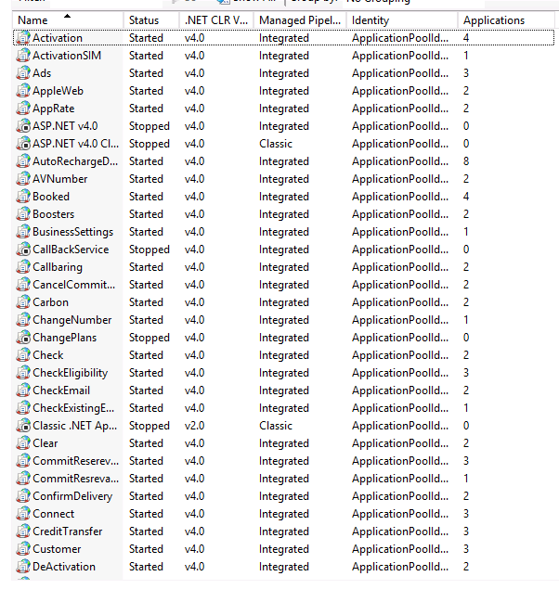
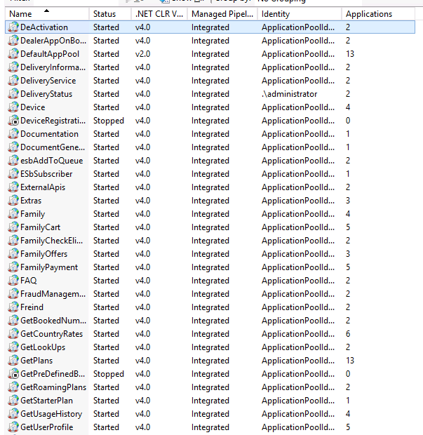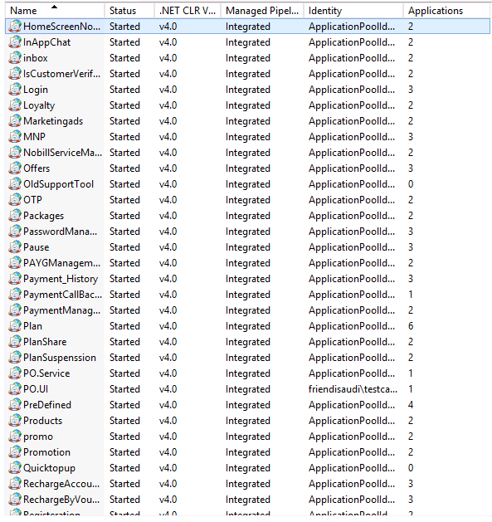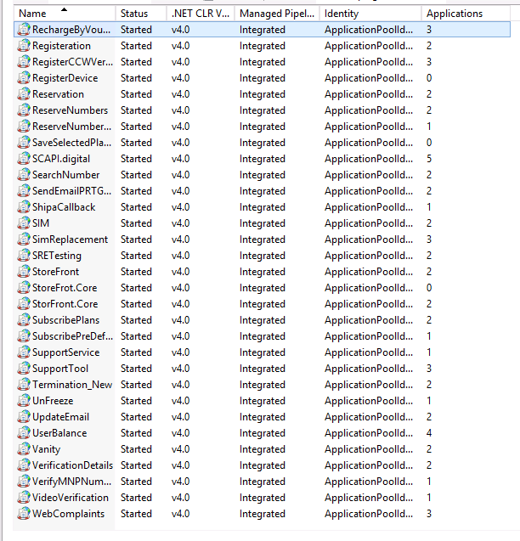
- 3.3 API Activation

- 3.4 SC Database Queries and Their Purpose

1. Check Booked Numbers Status
SELECT * FROM Booked_Numbers WHERE BookedNumber = '' ORDER BY 1 DESC;
SELECT * FROM Booked_Numbers WHERE regid = '' ORDER BY 1 DESC;
SELECT * FROM Booked_Numbers WHERE email = '' ORDER BY 1 DESC;
Purpose:
To retrieve the status of a booked number using BookedNumber, regid, or email.
Status Indicators:
- ReservationStatus = 1 → Reserved but not paid
- ReservationStatus = 3 → Reserved and paid
- BookingStatus = 1 → Activated
- BookingStatus = 0 → Paid, but not yet activated
- ReservationStatus = 4 → Customer canceled the reservation
- ReservationStatus = 5 → Auto-canceled due to expiry

2. Check Customer Registration Status
SELECT * FROM Registration WHERE Email = '';
SELECT * FROM Registration WHERE id = '';
Purpose:
To verify if the customer is registered and retrieve their information, including the Customer ID.
3. Check User Plan
SELECT * FROM UserSelectedPlan WHERE RegId = '';
SELECT * FROM UserSelectedPlan WHERE bookednumberid = '';
Purpose:
To confirm the user’s selected plan and ensure it is properly linked to the relevant payment and booked number IDs.

4. Check Payment Status
SELECT * FROM servicepayment WHERE regid = '' ORDER BY 1 DESC;
SELECT * FROM servicepayment WHERE id = '';
SELECT * FROM servicepayment WHERE MSISDN = '' ORDER BY 1 DESC;
Purpose:
To verify the payment status of a customer and confirm if the transaction was successful.

5. Check Customer API Log
SELECT * FROM MethodTrace WITH (NOLOCK) WHERE regid = '' ORDER BY 1 DESC;
Purpose:
To track all API calls made by a specific customer through the app. Useful for debugging, auditing, and reviewing response times and flow.

6. Check API Exceptions
SELECT * FROM LOG WITH (NOLOCK) WHERE regid = '' ORDER BY 1 DESC;
Purpose:
To identify exceptions or errors triggered by customer actions or internal API processing.

4 SC Customer Account

This section offers a structured and detailed explanation of the Virgin Mobile KSA mobile application. It is designed to help users understand the layout, navigation, and functionality of the app.
- Overview:
The guide walks through each major section of the application, beginning with the Home Page and continuing through the app’s core features. Screenshots are provided throughout to enhance clarity and usability.
- Key Areas Covered:
- Home Page Navigation:
A snapshot of the user's account overview, including active plans and quick access to essential features.
- Payment Setup:
Step-by-step guide on adding and managing payment methods, including supported card types and saving card preferences.
- Usage Monitoring:
Visual representations of data, call, and SMS usage categorized by time and service type.
- Wallet and Recharge Management:
Instructions on setting primary payment methods, viewing wallet balance, and automating top-ups.
- Support and Settings:
Access to the help center, promotional codes, complaint submission, and logout functionality.

- 4.1 Home Page

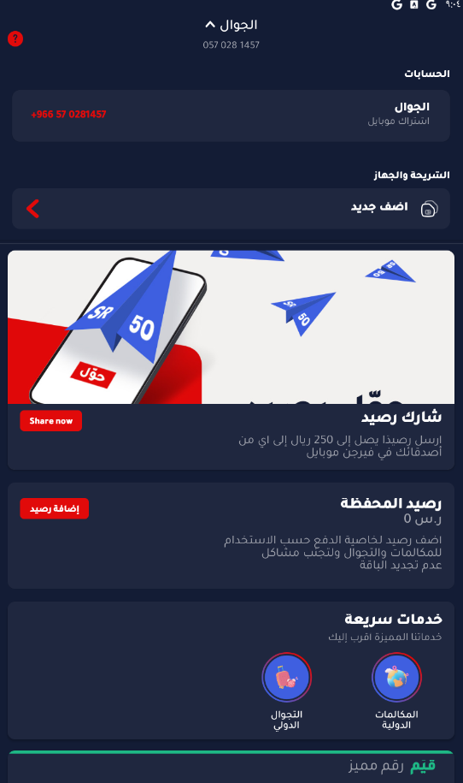
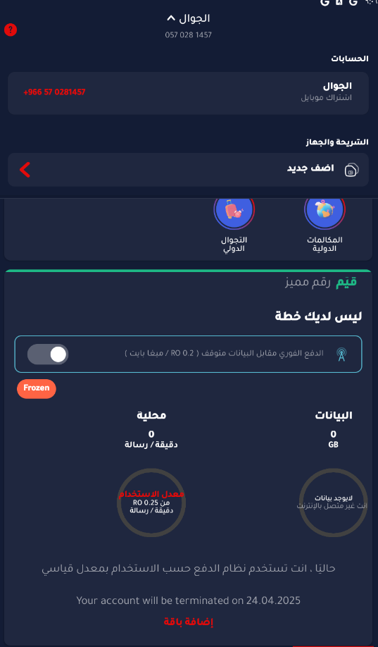

- 4.2 Payment Method
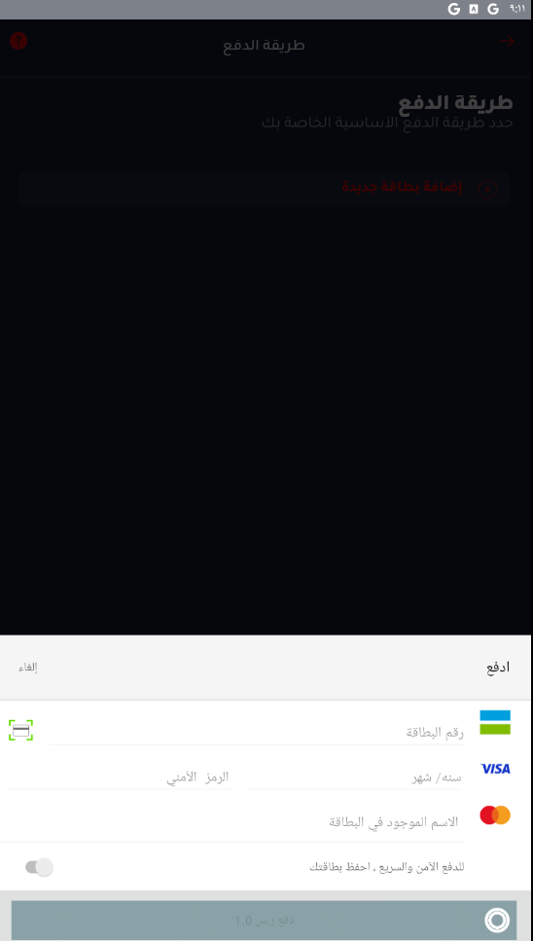

This section provides users with a secure interface to add and manage their payment methods.
- Features:
- Card Information Input:
Users are required to input the following card details:
  - Card Number
  - Expiry Date
  - CVV (Card Verification Value)
  - Cardholder Name (as printed on the card)
- Save Card Option:
An optional toggle allows users to securely save their card information for future transactions.
- Supported Card Types:
The system currently supports:
  - VISA
  - MasterCard
- Action Buttons:
  - Pay: Confirms and submits the payment.
  - Cancel: Cancels the payment process and returns the user to the previous screen.
This functionality ensures a smooth and secure user experience during the payment process.

- 4.3 Payment Preferences

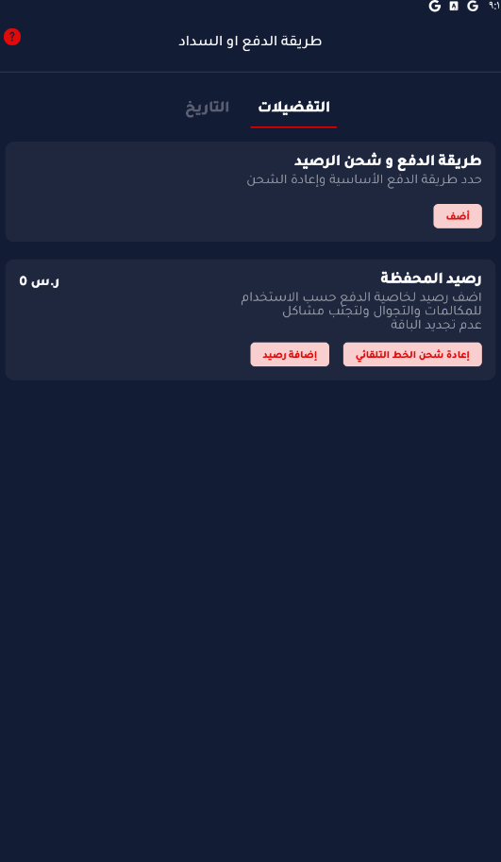

This section enables users to configure their recharge settings and manage their wallet balance effectively.
- Features:
- Primary Payment Method Configuration:
Users can select and set their preferred payment method to be used by default for recharges.
- Wallet Balance Overview:
Displays the current wallet balance.
(Example: 0 SAR shown for reference.)
- Recharge Options:
  - Manual Recharge: Users can manually add funds to their wallet as needed.
  - Automatic Recharge: Allows users to enable automated top-ups based on predefined conditions.
This functionality helps ensure a seamless and customizable experience for managing wallet funds and recharges.

- 4.4 Usage History
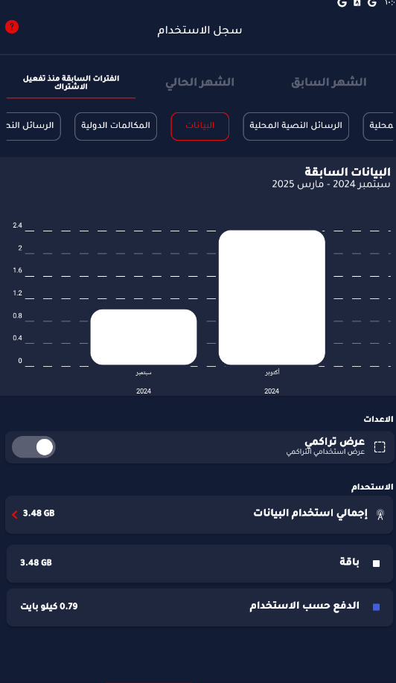

This section offers a comprehensive breakdown of the user's activity across various service categories and time periods.
- Key Features:
- Data Usage Visualization:
Displays a visual graph representing monthly data consumption.
- Category Tabs:
Allows users to view detailed usage statistics across categories such as:
  - Local Calls
  - International Calls
  - SMS
  - Data
- Cumulative View Toggle:
Users can switch between viewing usage by month or as a cumulative total.
- Detailed Usage Breakdown:
Provides insights into total usage, distinguishing between consumption through:
  - Plan allowances
  - Pay-as-you-go charges
This overview helps users track and manage their communication habits effectively.

- 4.5 Additional services and settings
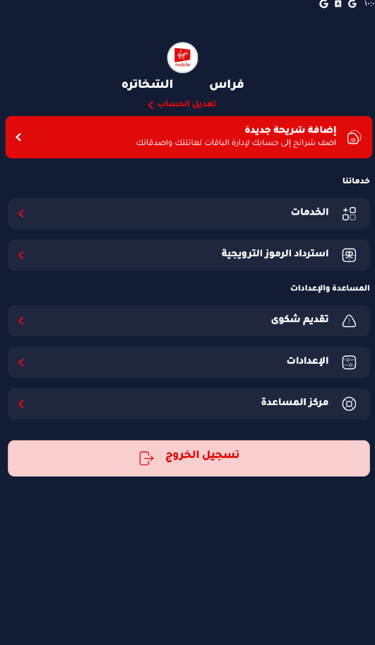

This section provides access to additional account features, service management options, and user settings.
- Key Features:
- SIM Management:
Allows users to add and manage Virgin Mobile SIM cards directly within the app.
- Service Management:
View, modify, or activate service-related features tied to the account.
- Promotional Codes:
Enter promo codes to redeem discounts, special offers, or bonuses.
- Help & Support:
Access customer support resources, submit complaints, and configure general app settings.
- Secure Logout:
Option to log out of the application safely and protect user account data.

5 Customer Onboarding

This section outlines the onboarding process for new customers within the Virgin Mobile KSA mobile application. It guides users through each step from the initial number selection to reaching the login screen.
- Onboarding Steps:
- Number Selection:
Customers begin by choosing a preferred mobile number.
- Plan Selection:
After selecting a number, users browse and select a mobile plan that suits their needs.
- Eligibility Verification:
The app validates user eligibility based on identity and system checks (e.g., national ID, SIM limits, etc.).
- Account Login Page:
Upon successful verification, users are directed to the account login or registration screen to continue.

- 5.1 Choose Your Number
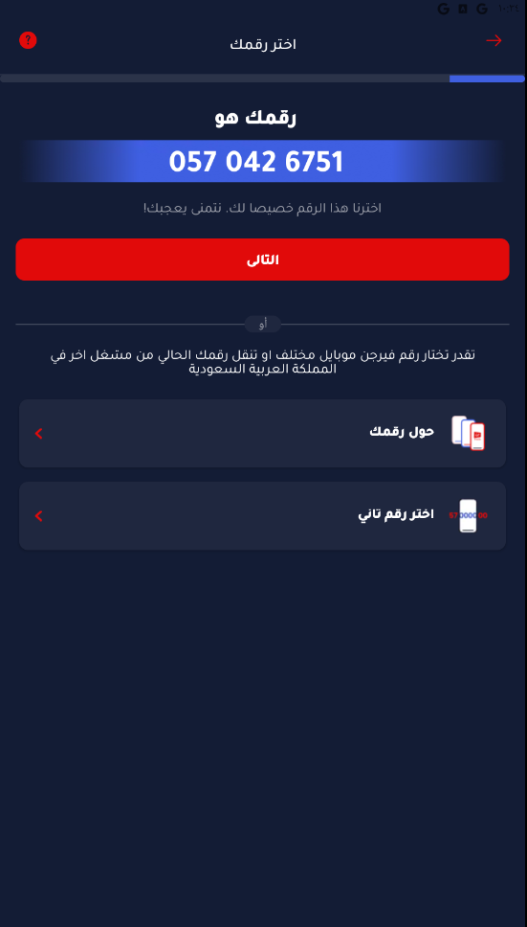

The onboarding process begins with selecting a mobile number. Virgin Mobile provides a suggested number (e.g., 057 042 6751) by default, which the user can either accept or replace with a different available number.
Alternatively, users have the option to port an existing number from another service provider within Saudi Arabia, allowing them to retain their current number while switching to Virgin Mobile.
This step ensures flexibility and convenience, accommodating both new and existing mobile users.

- 5.2 Select Your Plan
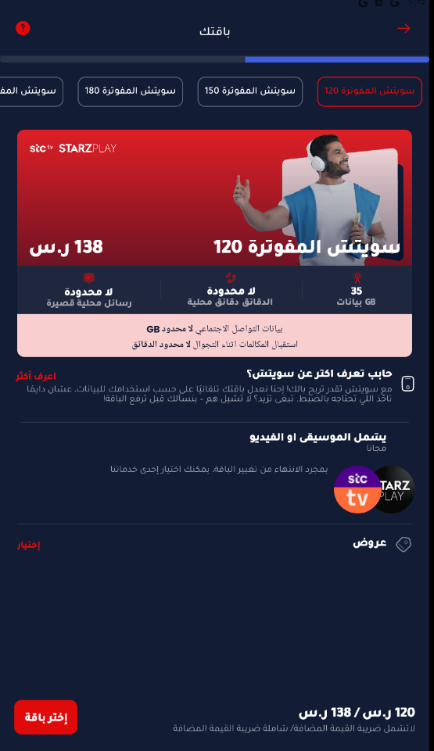

After selecting a mobile number, the user is guided to choose a postpaid plan that best fits their needs. Virgin Mobile KSA provides a variety of flexible plans with different data allowances and value-added services.
- Available Postpaid Plans:
- Switch 120
  - 35 GB of data
  - Unlimited local minutes
  - Free access to STARZPLAY
- Switch 150 / Switch 180
  - Increased data allowances
  - Additional local minutes and SMS
  - Enhanced features such as extra social media data and free streaming services
Each plan is presented with its monthly price and a summary of key benefits, making it easy for the user to compare options before proceeding.

- 5.3 Verify Eligibility

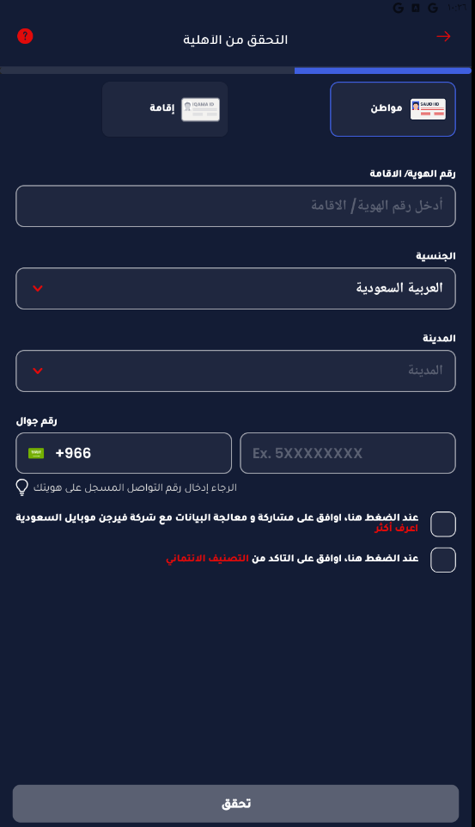
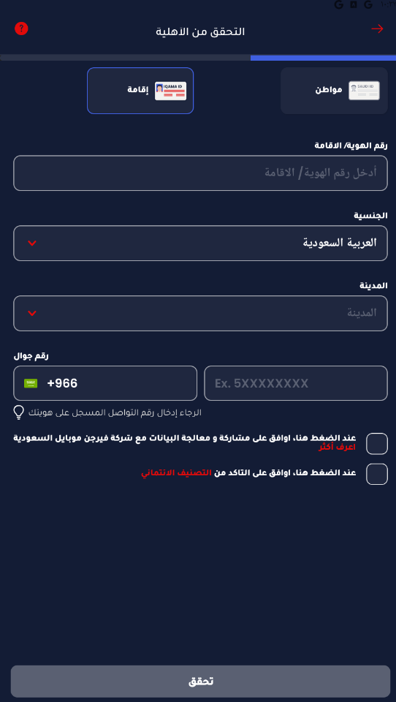

After selecting a plan, users must complete an eligibility verification step, which varies based on their residency status (Saudi citizen or Iqama holder).
Required Information:
- National ID (for citizens) or Iqama Number (for residents)
- Nationality and City of Residence
- Mobile Number registered with Absher
User Consents:
To proceed, users must agree to two mandatory consent options:
- Consent to share and process personal data
- Consent to verify credit rating eligibility
This step ensures compliance with regulatory and financial guidelines before proceeding with the account setup.

- 5.4 Optional: Explore Available Plans Before Registration

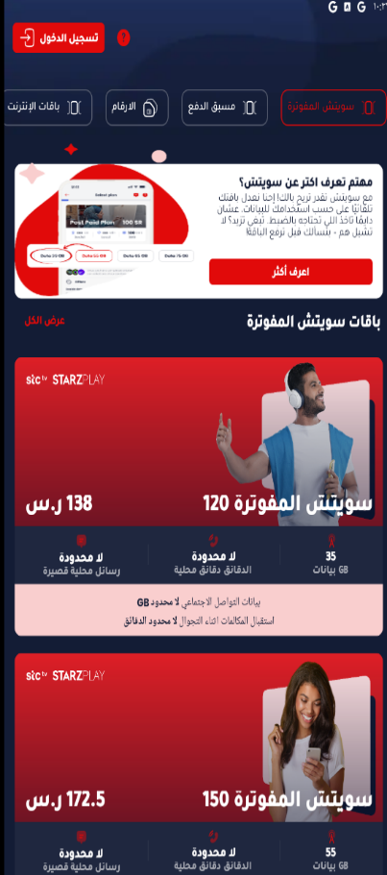
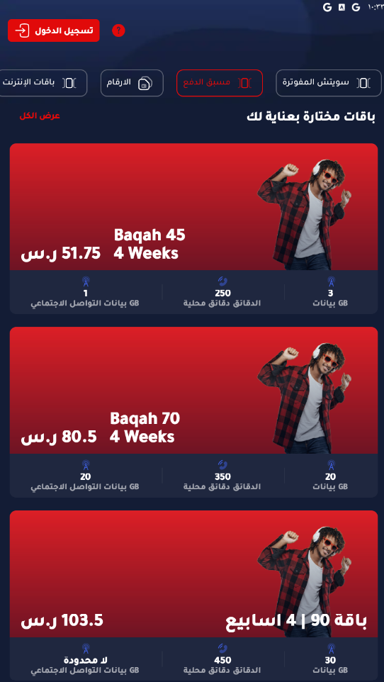

Before beginning the registration process, users have the option to explore the app’s offerings, including plans and number options:
- Postpaid Plans: Various Switch packages bundled with benefits such as streaming service access.
- Prepaid Bundles: Short-term recharge options including Baqah 45, 70, and 90.
- Number Selection: Users can browse available standard and premium mobile numbers, with pricing displayed where applicable.
This feature allows users to compare services and make informed decisions prior to registration.

- 5.5 Final Step: Login or Register an Account
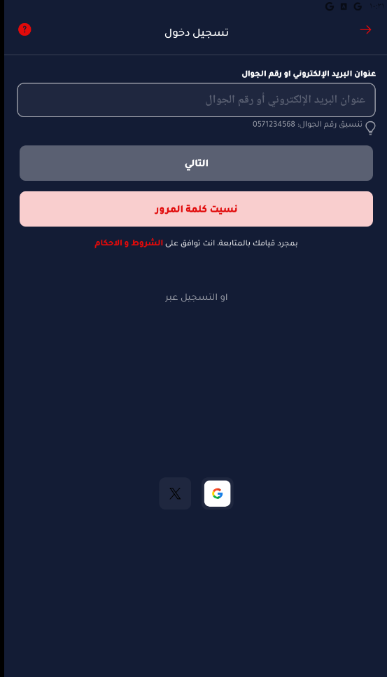
After completing the onboarding process, users are directed to the login page where they can:
- Sign in using their email address or mobile number.
- Use alternative login options via Google or Apple ID.
- Recover their password through a dedicated password recovery feature if forgotten.
Users must accept the terms and conditions before proceeding to access their account.

6 Activation Engine
This document provides a formal business overview of the Activation Engine used in Virgin Mobile KSA. It explains the activation channels, system architecture, and the business value of the activation engine, focusing on operational roles and benefits.

- 6.1 What is the Activation Engine?
The Activation Engine is a core system in Virgin Mobile KSA responsible for provisioning mobile services to new and existing customers. It processes and manages service activations, plan assignments, number allocations, SIM registrations, and ownership transfers. This engine acts as the central coordinator between front-end channels and backend telecom systems.

Server Name | IP Address | Status | Username | Password | Physical Path
Database Server (DB) | 10.4.95.44 | Active | AppDBAccess | t4v-25QByD
Activation Application Server 1 | 10.125.9.101 | Active | administrator | P#ssw-rd098 | C:\LeadingPoint\CAS.Digital.Prod
Activation Application Server 2 | 10.125.9.102 | Active | administrator | P#ssw-rd098 | C:\LeadingPoint\CAS.Digital.Prod

- 6.2 Activation API

- 6.3 Activation Channels
The Activation Engine receives activation requests from two main channels:
1. SC (Self-Care) App:
- This is the official Virgin Mobile KSA mobile application used by customers.
- It enables users to complete the onboarding process, choose numbers and plans, and activate SIM cards.
- All customer interactions, including identity verification and activation, are processed through this app.
2. Dealer App:
- A dedicated mobile application used by authorized dealers.
- Used to facilitate new activations and SIM distribution.
- Sends real-time requests to the Activation Engine via secure APIs.

- 6.4 Technical Architecture (Back-End Systems)
The Activation Engine operates across multiple servers:
- Database Server: Hosts the core activation database storing customer, activation, and log data.
- Application Servers: Handle activation workflows and logic.
- The system includes secure access credentials and structured folder paths for operational execution.

- 6.5 Core Functionalities of the Activation Engine
The Activation Engine performs several critical operations:
- Number Activation (New/Existing)
- SIM Replacement and Ownership Transfer
- Plan Activation and Termination
- Customer ID Verification
- Logging and Error Tracing
- Process Monitoring and API Call Tracing

- 6.6 Database

  - Check Activation Status
SELECT * FROM Activation WHERE MSISDN = '' ORDER BY 1 DESC;
SELECT * FROM Activation WHERE IMSI = '' ORDER BY 1 DESC;
SELECT * FROM Activation WHERE NobillAccountnumber = '' ORDER BY 1 DESC;
Purpose: Retrieves activation status using MSISDN, IMSI, or NobillAccountnumber.
isactive = 1: Number is active
isactive = 0: Number is terminated

  - Check Semati Status
SELECT TOP (1000) *,
CASE
WHEN requesttype = '2' THEN 'AddSIM'
WHEN requesttype = '5' THEN 'CancelSIM'
WHEN requesttype = '1' THEN 'NewActivation'
WHEN requesttype = '4' THEN 'TerminateActivation'
WHEN requesttype = '17' THEN 'TransferOwner'
WHEN requesttype = '7' THEN 'VerifyCustomerId'
WHEN requesttype = '18' THEN 'TransferOperator'
WHEN requesttype IS NULL THEN 'Login'
END AS requestTypeName
FROM [Activation].[dbo].[SematiCallReport]
WHERE msisdn = '966571562305'
ORDER BY TimeStamp DESC;
Purpose: Displays customer-initiated actions (e.g., activation, cancellation) and their corresponding responses from Semati.

  - Check Error Logs
SELECT TOP (2000) *
FROM [Activation].[dbo].[ErrorLog] WITH (NOLOCK)
WHERE ErrorDescription LIKE '%MSISDN%'
ORDER BY 1 DESC;

SELECT TOP (1000) *
FROM [Activation].[dbo].[ErrorLog]
WHERE errortype = 'Generic Error'
ORDER BY 1 DESC;

SELECT TOP (1000) *
FROM [Activation].[dbo].[ErrorLog] WITH (NOLOCK)
WHERE Source = 'API Name'
ORDER BY 1 DESC;
Purpose: Identifies general and specific errors, particularly those triggered by API interactions or containing MSISDNs.

  - Check Process Details
SELECT TOP (1000) *
FROM [Activation].[dbo].[ProcessTrace]
WHERE UIDValue = 'MSISDN'
ORDER BY 1 DESC;

SELECT TOP (1000) *
FROM [Activation].[dbo].[ProcessTraceDetails]
WHERE ProcessTraceID = ''
ORDER BY 1 DESC;
Purpose: Tracks the flow of processes (activations, terminations, etc.) and their corresponding API calls and system responses.

  - Check Semati Logs

SELECT TOP (2000) *
FROM [Activation].[dbo].[SematiServiceCallLog]
ORDER BY 1 DESC;

SELECT TOP (2000) *
FROM [Activation].[dbo].[SematiServiceCallLog]
WHERE RequestText LIKE '%MSISDN%'
ORDER BY TimeStamp DESC;

SELECT TOP (2000) *
FROM [Activation].[dbo].[SematiServiceCallLog]
WHERE DealerCode = '' AND Operation = 'API NAME' AND RequestType = 'process name'
ORDER BY TimeStamp DESC;

Purpose: Monitors communication with the Semati system, including request payloads, dealer activity, and errors for audit or troubleshooting.

